**Installation guide for 2021 Autodesk Inventor Professonal**

1. Run the Autodesk 2021 “setup.exe”. Setup Initialization.

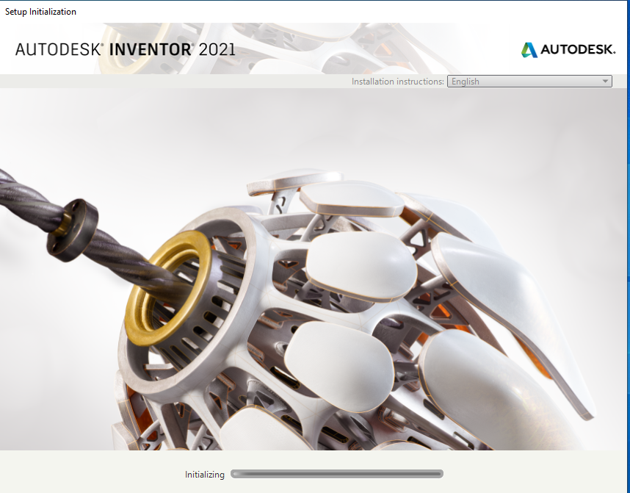

1. Click on the “Install” button.

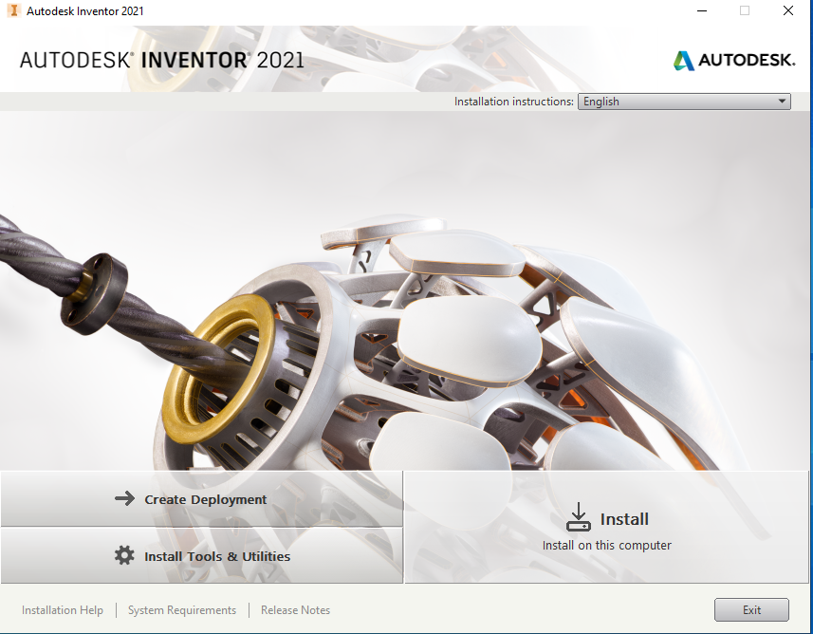

1. Read the License Agreement carefully then select “I accept” button and Click on “Next” button.

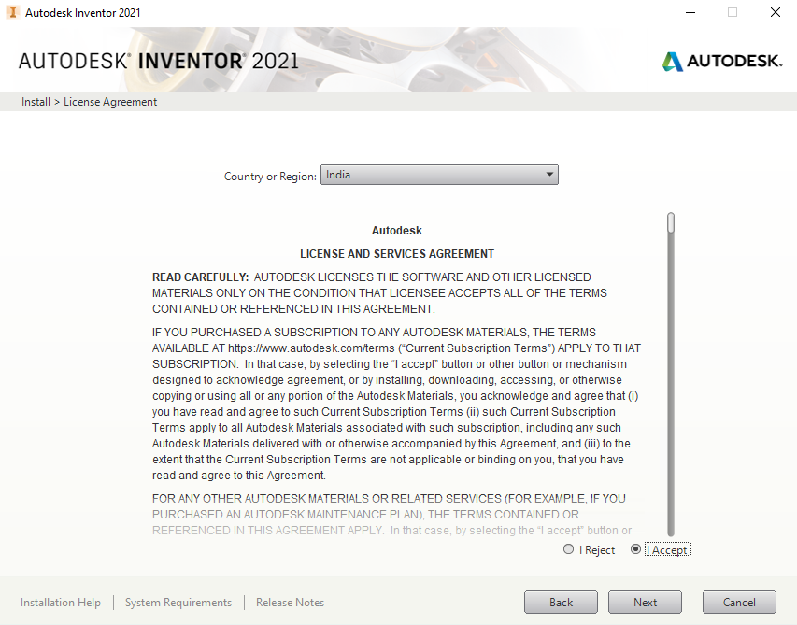

1. Choose the “Autodesk Inverter Professional 2021” product to install and Click on “Next” button.

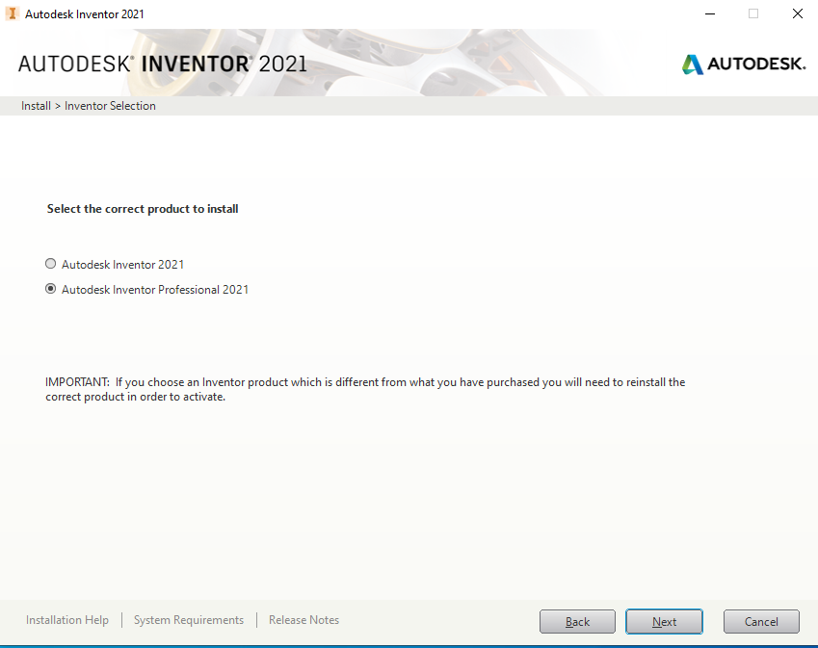

1. Select the Installation folder path from local drive. Choose the default folder path and Click on “Install” button.

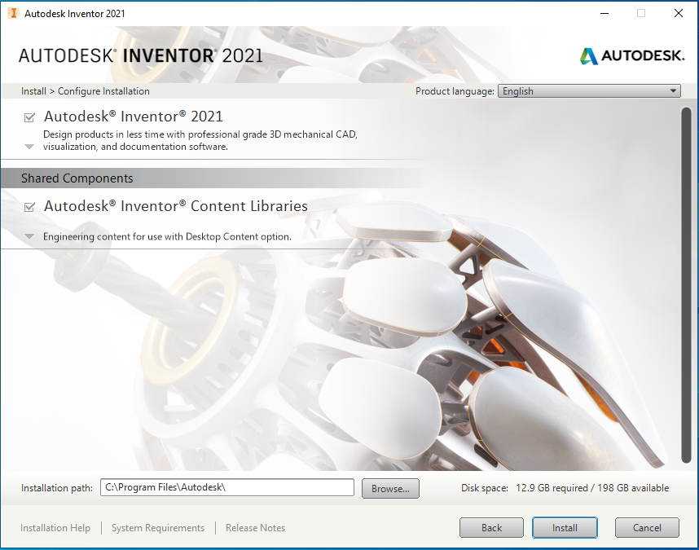

1. Wait a several minute for the installation complete.

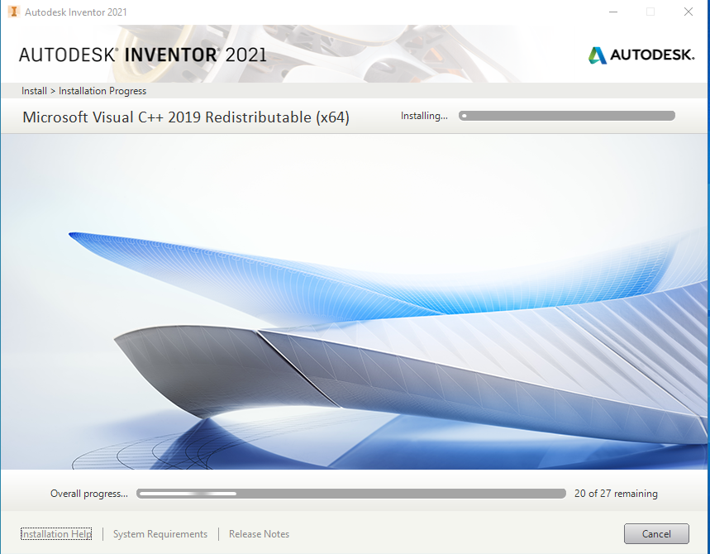

1. Installation is finished, and Click on “Finish” button.

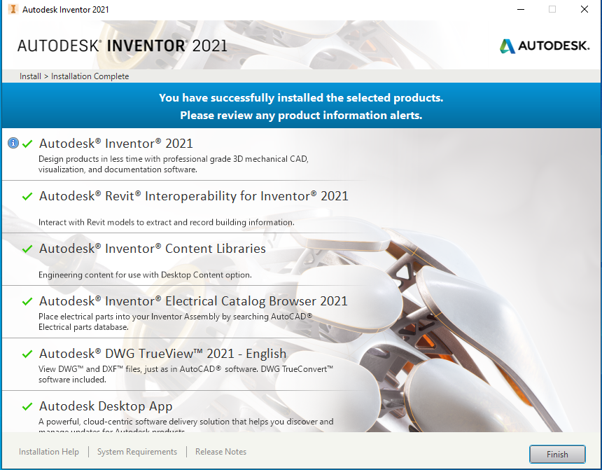

1. Click on “Yes” button for restart system.

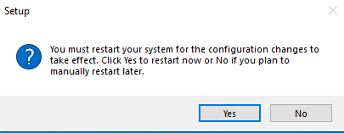

1. Launch Autodesk Inverter 2021. And Select “Use a network license” option. 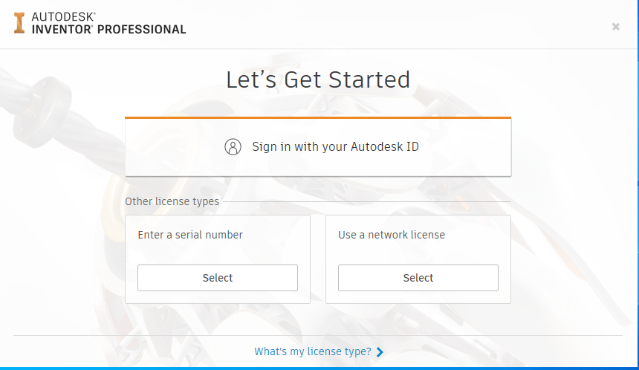
2. “Specify a license server”. Select Single Licence Server model and Enter the Server IP Address is “**172.31.1.12”**

